# Game Design – Final Project Template

High Level Concept/Design

## (Module 3) Working title:

*Hyper-Ball*

## (Module 3) Concept statement:

*Skill based game that pairs reaction speed and hand-eye coordination by drawing lines to prevent the ball from getting to the bottom of the screen.*

## (Module 3) Player experience and game POV:

*The game consists of one level the progressively gets harder. The player views the playing field from the side and watches as a ball falls from the top of the screen. The player draws lines below the ball to prevent it from hitting the bottom of the screen. The ball bounces off the line and deletes it, forcing the player to keep drawing lines to keep the ball up.*

## (Module 3) Genre(s):

Product Design

*This is an action game.*

## (Module 7) Visual/audio Style:

*Visual style: I am using semi-futuristic UI elements that have some sharp angles with a background of scrolling stars. The elements help accentuate the feel of the game as these graphics are normally associated with space/sci-fi elements which then lends itself to a generally more tense gameplay experience.*

*Audio style: For both the menu and the background music for the game, I am using fast pace music to help increase the feeling of needing to react quickly.*

## (Module 3) Platform(s) and primary technology:

*The target platform for this game is PC and will be created using Unity.*

## (Module 3) Schedule and scope

*Week 1 – Nov 5: Create core design document, begin core gameplay loop.*

*Week 2 – Nov 12: Finish core gameplay loop, add sound, begin difficulty progression.*

*Week 3 – Nov 19: Finish difficulty progression, begin UI and Upgrade mechanics.*

*Week 4 – Nov 26: Continue UI and upgrade mechanics.*

*Week 5 – Dec: 3 Finish UI and Upgrade mechanics, begin polish and bug fixes.*

*Week 6 – Dec 10: finish polish and publish.*

## (Module 4) Game world fiction:

*This game has no narrative.*

## (Module 6) Objectives and Progression

Detailed Game Design

*The player will be greeted by a “Welcome” screen that has a “Play” button as the largest button on top, then an “Upgrades” button, an “Settings” button, then finally an “Exit Game” button.*

*Upon pressing “Play”, the game starts where a ball will drop, and the player will click and drag on the play area to create a line. When the ball hits the line, the line will disappear. The player will be limited to one line initially, with plans to have upgrades to allow more lines to be drawn at the same time. Once the player loses all their lives, a “Game Over” screen will appear with the same options as the “Welcome” screen.*

*The “Upgrades” button will open a menu with different selections where the player can purchase upgrades to make the game easier, such as lowering the final speed limit of the ball, being able to place multiple lines, and purchasing and upgrading a shield at the bottom of the screen to save the player if they miss the ball.*

*The “Options” menu will allow players to turn the SFX or music on or off as well as control the volume.*

## (Module 6) Interactivity

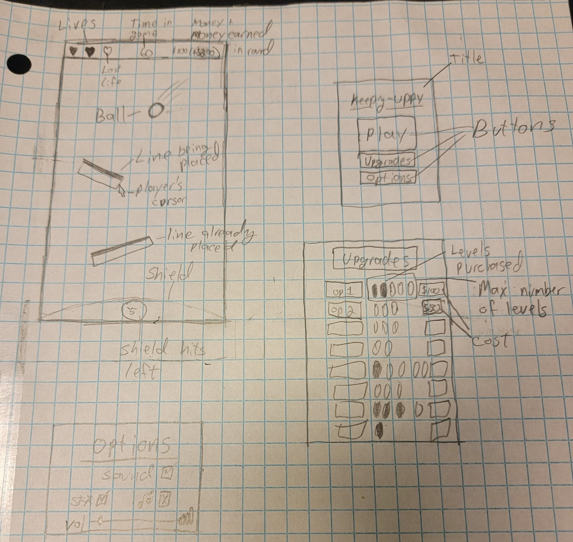

## (Module 4) Internal structure

* *Ball*
  + *Spawns from random location at top of screen*
  + *Affected by gravity*
  + *Has 1.2 bounciness physics material*
  + *Destroyed at bottom of screen*
    - *waits 2 seconds, then spawns another ball.*
  + *Sounds:*
    - *Instantiated: pop sound*
    - *Bounces: boing*
      * *Destroyed: Crash*
* *Line*
  + *Created where player clicks mouse button 1*
  + *Stretches and rotates while player keeps mouse button 1*
  + *When player lifts mouse button 1, it activates the collider and sets its bounds to match the line.*
  + *Not affected by gravity*
  + *Deleted when ball hits*
  + *Each line has a max length. Starts at 1 and can be upgraded to 1.4 (Play area is about 6.5 units across)*
  + *Limited to 1 line initially, but can be upgraded to 4.*
* *Lives*
  + *Non-interactable*
  + *Top-left overlay*
  + *Shows how many lives player has remaining by showing brighter hearts for lives left, and darker hearts for lives lost*
* *Timer*
  + *Non-interactable*
  + *Top-middle overlay*
  + *Show how long the player has survived*
  + *Starts at 0 each playthrough and counts up*
* *Money*
  + *Non-interactable*
  + *Top-right overlay*
  + *Shows how much money player has and how much the player will earn upon defeat in the format*
    - *$ has (+$will earn) – ex. $50 (+$35)*
  + *Money is used to purchase upgrades on main screen.*
  + *Money is earned*
    - *+$1 per 1 second*
    - *+$5 per bounce on line*

## (Module 4) Core loops

* *Main gameplay loop:*
  + *Player will start the game with a blank scene that has an overlay of their Lives, a timer, and their money (currently at 0)*
  + *After 2 seconds, a ball will fall and the game will start.*
  + *Player will click and drag to draw lines to try and keep the ball from hitting the bottom of the screen.*
  + *When the last ball hits the bottom of the screen, a life is lost*
  + *Once all lives are lost, it will display a “Game Over” screen with the option to play again, or go to the main menu*
  + *On the upgrade screen, user can choose to upgrade different options (if they have enough money)*
* *Macro scope:*
  + *Get the highest score they can*
* *Intermediate scope:*
  + *Earn money to buy upgrades*
* *Micro scope:*
  + *Stop the ball from hitting the bottom*
* *Main feedback loop:*
  + *Positive*
    - *Player earns money based on time played and how many times the ball was bounced*
    - *Player can use this money to buy upgrades to make the game easier*
  + *Negative*
    - *As the player plays longer, the ball’s size gets smaller to a limit*
    - *Once the limit is hit, the ball’s max speed slowly increases to a limit.*
* *Why is this engaging?*
  + *Players must react quickly to the angle of the ball and make sure where they’re creating the line is close enough to the path of the ball that it can reach it.*
  + *This plays on the “easy to learn, hard to master” principal.*